WHITE MOUNTAIN LAKE COMMUNITY ASSOCIATION
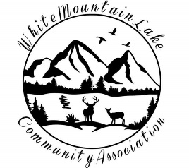
Harold Albertson * Debi Bismarck * Scott Hurst * Shirley Wyatt

BOARD OF DIRECTORS MEETING

DRAFT MINUTES

COMMUNITY CENTER

1785 EDMONDS CIR, SHOW LOW, AZ 85901
January 18, 2022 * 6:30pm

- Called to order: 6:40PM
- Roll Call: Harold Albertson, Scott Hurst, Debi Bismark telephonically
- Minutes: Scott motioned to accept the November, 2021 Minutes. Debi seconded. All in favor.
- Financial Reports by the Treasurer: see section V.f.
- Business:
  - Committee Reports – None, per Jessica DeLaney prior to the meeting
  - Harold made motion to remove Shirley Wyatt from board after three absences in a row, per bylaws. There has been no contact, nor return contact from her.
  - Harold makes motion to appoint Diane Martinez to the board. Seconded by Scott. Approved
  - A motion was made to accept November minutes. Seconded and approved.
  - There was no December meeting due to lack of quorum (Shirley Wyatt absent without notification)
  - Financial report for November and December tabled until next meeting in February.
  - Re: Debi getting discounted fencing. The manager said to wait till after first of the year; she will call back end of January
  - Environmental grant; Mannie Bowler will be here next meeting to discuss and have Q&A about a recycling grant she has from ASU. Will advertise online to get the word out.
  - Minimum raise increased, so Aria automatically receives raise. Harold made motion to increase Diane’s wage by the same 5.3%. Scott seconded. Scott will contact CPA.
  - Discussing old contract that needs to be updated; want to get card reader and electronic postage meter, but requires dedicated VPN, all at our cost.
  - Scott motions to eliminate pest control; Harold and Debi second
- Adjournment Harold motioned to adjourn the meeting at 7:15pm. Debi seconded. All in favor.
- Open Discussion

Respectfully submitted,

Kelly Albertson, acting for
Secretary of the White Mountain Lake Community Association

