WHITE MOUNTAIN LAKE COMMUNITY ASSOCIATION
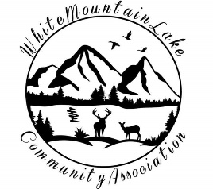
Harold Albertson*Debi Bismarck*Scott Hurst*Diane Martinez

COMMUNITY CENTER
1785 EDMONDS CIR, SHOW LOW, AZ 85901
February 15, 2022 * 6:30pm

AGENDA

- I. Call to order - Pledge of Allegiance
- II. Roll Call of the Board of Directors
- III. Discussion & Approval of prior Minutes
- IV. Financial Report
- V. Business
  - Committee Reports
  - Mannie Bowler to discuss Environmental Grant and recycling opportunities
- VI. Adjournment
- VII. Open Discussion

Respectfully submitted,

Kelly Albertson, acting for the
Secretary of the White Mountain Lake Community Association

VIRTUAL MEETING INFO
Join Zoom Meeting
https://zoom.us/join
Meeting ID: 724 275 6085
Password: 3RTT4f

