WHITE MOUNTAIN LAKE COMMUNITY ASSOCIATION
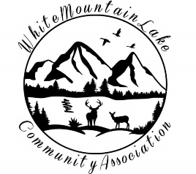
Harold Albertson*Debi Bismarck*Diane Martinez*

COMMUNITY CENTER
1785 EDMONDS CIR, SHOW LOW, AZ 85901
Tuesday, June 21, 2022 - 6:30 pm

AGENDA

- I. Call to order - Pledge of Allegiance
- II. Roll Call of the Board of Directors
- III. Discussion & Approval of prior Minutes
- IV. Financial Report for May 2022.
- V. Business
  - Committee Reports
  - Secretary Reports: Membership Renewals due in June. Receipt of two Comment Cards.
  - WMLCA Upcoming Election for Board Members.
  - Cell Tower Proposal.
- VI. Adjournment
- VII. Open Discussion

Respectfully submitted,

Diane M Martinez
Secretary of the White Mountain Lake Community Association

VIRTUAL MEETING INFO
Join Zoom Meeting
Meeting ID: 876 5194 7354
Password: L0BC67

.

