WHITE MOUNTAIN LAKE COMMUNITY ASSOCIATION
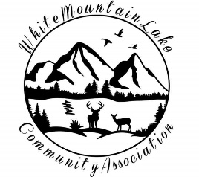Harold Albertson*Debi Bismarck*Diane Martinez*

COMMUNITY CENTER
1785 EDMONDS CIR, SHOW LOW, AZ 85901
April 12, 2022 - 6:30 pm

AGENDA

- I. Call to order - Pledge of Allegiance
- II. Roll Call of the Board of Directors
- III. Discussion & Approval of prior Minutes
Before reports - we want to welcome new members Phyllis and Steven Schaeffer.
- IV. Financial Report for March 2022
- V. Business
  - Committee Reports
  - Request for a change of monthly meeting day did not meet with enthusiasm. It appears that the monthly meeting will continue to be held on the 3rd Tuesday.
  - What to do about the cancelled TPT license.
  - Annual Report to the Arizona Corporation Commission is due in June. Anyone interested in joining the Board at this time? Would help to have a full board before the Annual Report is submitted.
  - Report that Matthew Villareal will be doing the monthly cleaning. No one has volunteered as yet for pest control.
  - Received a forwarded email from Sandee McKinlay requesting the Association's help in setting up meetings at Sandbaggers for 2022 candidates. Interested?
  - Without Charley Ritter's carpentry skills, it seems that a ramp to replace the steps at the Post Office has been tabled. Community feedback had been that a ramp is preferable to the steps. Put this issue aside permanently?
  - Report from the Post Office: how new employee is doing and Aria's resignation.
- VI. Adjournment
- VII. Open Discussion

Respectfully submitted,

Diane Martinez
Secretary of the White Mountain Lake Community Association

VIRTUAL MEETING INFO
Join Zoom Meeting
https://zoom.us/join
Meeting ID: 876 5194 7354
Password: L0BC67

NOTE: as of March 2022 - this is a new meeting ID.

