WHITE MOUNTAIN LAKE COMMUNITY ASSOCIATION
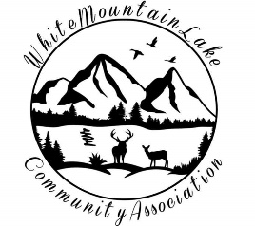
Harold Albertson * Debi Bismarck * Scott Hurst * Shirley Wyatt

COMMUNITY CENTER
1785 EDMONDS CIR, SHOW LOW, AZ 85901
January 18, 2022 at 6:30pm

AGENDA

- I. Call to order - Pledge of Allegiance
- II. Roll Call of the Board of Directors
- III. Discussion & Approval of prior Minutes
- IV. Financial Report for Month & Year
- V. Business
  - Committee Reports
  - Environmental concerns – a liason with Navajo county has grant from ASU – committee to handle that?
  - Rural Development Grant
  - Openings on Board
    - Minimum 1 board seat opening (one person interested)
  - Raises for Aria and Diane
    - Minimum wage increased 5.3% for Aria
    - Provide similar raise for Diane as lead clerk?
- VI. Adjournment
- VII. Open Discussion

Respectfully submitted,

Kelly Albertson, acting for the
Secretary of the White Mountain Lake Community Association

VIRTUAL MEETING INFO
Join Zoom Meeting
https://zoom.us/join
Meeting ID: 876 5194 7354
Password: L0BC67

